1

2

|  |  |
| --- | --- |
| Motor Pin |  |
| 1 | GND |
| 2 | Encoder A |
| 3 | VCC |
| 4 | Encoder B |
| 5 |  |
| 6 | Switch |
| 7 | Motor + |
| 8 | Motor - |
| 9 | Motor + |
| 10 | Motor - |

Front view of the Motor

Direction shown is defined as RIGHT

In C : 7404 4

In A : 7404 pin 3

In B : 7404 pin 1

Direction pin of uc

1: Drive right

Motor 7

In A : 7404 pin 2

Motor 7

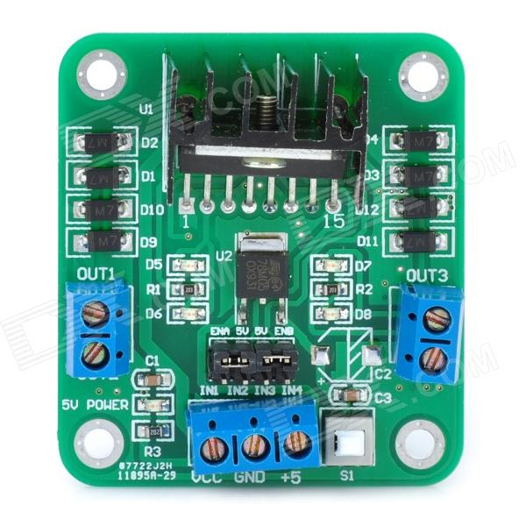

Motor 9

Motor 9